**Correlation of 2022 dreadful flood and climatic factors in Bangladesh with risk reduction strategies**

Md. Aminul Islam1, 2*, Mohammad Nayeem Hasan3, Tahmid Anam Chowdhury4, Sarawut Sangkham5, Lamia Mahzabin6, Md. Sajadul Alam6, Adhena Ayaliew Werkneh7, Md. Jakariya6*, Prosun Bhattacharya8*

1Department of Microbiology, Noakhali Science and Technology University, Noakhali-3814, Bangladesh.

2Department of Microbiology, President Abdul Hamid Medical College, Karimganj, Kishoreganj, Bangladesh.

3Department of Statistics, Shahjalal University of Science and Technology, Sylhet 3114, Bangladesh.

4Department of Geography and Environment, Shahjalal University of Science and Technology, Sylhet, 3114, Bangladesh

5Department of Environmental Health, School of Public Health, University of Phayao, Muang District, Phayao 56000, Thailand

6Department of Environmental Science and Management, North South University, Bashundhara, Dhaka-1229, Bangladesh.

7Department of Environmental Health, School of Public Health, College of Health Sciences, P.O. Box 1871 Mekelle, Ethiopia

8COVID-19 Research, Department of Sustainable Development, Environmental Science and Engineering, KTH Royal Institute of Technology, Teknikringen 10B, SE-114 28 Stockholm, Sweden.

aminul@pahmc.edu.bd

[nayeem5847@gmail.com](mailto:nayeem5847@gmail.com)

tahmidanam@gmail.com

[sarawut.sa@up.ac.th](mailto:sarawut.sa@up.ac.th)

lamia.mahzabin@northsouth.edu

sajadul.saimon@northsouth.edu

adhenaayalew@gmail.com

md.jakariya@northsouth.edu

**\* Corresponding authors**

**Md. Aminul Islam, MSc**

Lecturer, Department of Microbiology  
President Abdul Hamid Medical College Hospital, Kishoreganj (PAHMCH)  
Senior Research Assistant, NSTU Covid-19 Lab, Department of Microbiology, NSTU  
Lab Incharge, Advance Molecular Lab, PAHMCH  
Data Assistant, MIS, DGSH, Chittagong, Bangladesh  
COVID-19 Lab Consultant, DGSH (ERP Project)  
Phone/whats app: +8801734452665  
E-mail: [aminulmbg@gmail.com](mailto:aminulmbg@gmail.com), [aminul@pahmc.edu.bd](mailto:aminul@pahmc.edu.bd)

Research Gate: <https://www.researchgate.net/profile/Md-Islam-1376>

Web address: <https://nstu.academia.edu/AMINULISLAM>

ORCID ID: 0000-0003-1091-9726 (<https://orcid.org/my-orcid?orcid=0000-0003-1091-9726>)

**Md. Jakariya, PhD**

Professor

Department of Environmental Science & Management (ESM)

&

Director

Climate Justice and Research Centre (CJR)

North South University

Bashundhara, Dhaka 1229, Bangladesh

Email: md.jakariya@northsouth.edu, [jakariya2009@gmail.com](mailto:jakariya2009@gmail.com)

Prosun Bhattacharya

Professor

COVID-19 Research @KTH, Department of Sustainable Development, Environmental Science and Engineering, KTH Royal Institute of Technology, Teknikringen 10B, SE-100 44 Stockholm, Sweden

Associate Editor: Journal of Hydrology

Editorial Board: Environment International

Editor in Chief: Groundwater for Sustainable Development

E-mail ID: prosun@kth.se

**Highlights**

1. First study investigates 2022 flood reasons in Bangladesh

2. Climate factors induce extreme dreadful flood disaster in Bangladesh

3. The temperature and water level negatively associated with flood

4. This wind speed, RH, and SP are positively linked with the water level in Sylhet city.

5. Results would be of significant for disaster policy-makers.

**Graphical Abstract**

E:\Manuscript\FLOOD\GA.tif

**Abstract**

Bangladesh has passed one of the most dreadful floods, with 79 deaths, thousands of injuries, and enormous economic loss, which was initiated on 17 May 2022 and mostly devastated two major districts of Sylhet -Sylhet and the northeastern division Sunamganj. This analysis deals with the possible reasons of the 2022 Bangladeshi flood with climatic factors. The ARIMAX statistical model calculated the correlation between daily water level and climatic variables. The statistical results of this analysis indicated a significant difference between non-flooded areas and flooded for weather factors and water levels. At the same time, Sunamganj showed the highest mean of wind speed (SD= 2.1), temperature (29.3) (SD= 2.1), rainfall, and surface pressure. This study's findings also indicated that the wind speed, RH, and SP are positively associated (Coefficient = 0.04, 95% CI: 0.02 to 0.30, 0.48 [0.20 to 1.16], 0.04 [-0.21 to 0.29], respectively) with the water level in Sylhet city, but the correlation of SP was not statistically significant with water level according to ARIMAX model. The temperature and WL have been found to be negatively associated (-0.16 [-0.58 to -0.27] and -0.32 [-0.41 to -0.02], respectively) with water level according to the ARIMAX model. The ARIMAX model explains 98.70% of the overall variation with 0.7901 RMSE and 0.5550 MAE. In Sunamganj city, the RH, SP, and WL are positively associated (0.65 [0.16 to 1.46], 0.17 [0.10 to 0.44], and 0.01 [0.01 to 0.05], respectively) with water level according to ARIMAX model. The WS and temperature have negatively associated (-0.04 [-0.29 to -0.01] and -0.24 [-0.72 to -0.11], respectively) with water level according to the ARIMAX model. The ARIMAX model explains 98.79% of the overall variation with 0.8069 RMSE and 0.5497 MAE. To the author's knowledge, this is the first study indicating the correlation between climatic factors and water level, focusing on the 2022 flood in Bangladesh, which will help policymakers and others take necessary steps and raise concerns.

**Keywords:** Flood 2022, Weather Forecasting, Climate change, Water level, Rainfall, Bangladesh, ARIMA, Risk mitigation

# 1. Introduction

Bangladesh is a developing agricultural country that will become a middle-income country in 2026 (Ahmed et al., 2021; Islam et al., 2021; Jakariya et al., 2021). Several parts of Bangladesh have been affected by severe floods due to incessant heavy monsoon rains and upstream water from the northeastern states of India, inundating large parts of the Sylhet division, especially Sylhet and Sunamganj districts (Gepp et al., 2022). Millions of people living on the Surma-Kushiyarariver's bank were stranded without food, potable water, and electricity (Noor et al., 2022). The floods started in Sylhet and Sunamganj on 17 May 2022 and gained destructive momentum from 17 June onwards, affecting more districts of Sylhet and Mymensingh division (Pervin et al., 2020). This crisis hit when people were recovering from the sudden flash floods of late May 2022. According to experts, this year's flood was worse than the ones that occurred in 1998 and 2004 (Sincavage et al., 2022). The sudden flash flood jeopardized around 7.2 million people, causing water logging in nine northeastern districts of Bangladesh (Baksi, 2022). Total 14 districts out of 64 districts of Bangladesh such as Sylhet, Sunamganj, Hobigonj, Moulvibazar, Mymensingh, Netrokona, Jamalpur, Sherpur, Rangpur, Panchagarh, Nilphamari, Lalmonirhat, Kurigram, Thakurgaon, Dinajpur and Gaibandha are flooded (Das et al., 2022).

A huge displacement of 481,827 people happened in the main four districts of Bangladesh: Sunamganj, Netrokona, Sylhet, Moulvibazar. More than 1.6 million children were threatened by a high risk of drowning, gender-based violence, and family separation due to overcrowded shelters (Masrur et al., 2022). As of Flood Forecasting and Warning Centre (FFWC), Sylhet and Sunamganj overflowed above danger level (up to 1 m) due to the heavy rains and flooded the low-lying areas the cities. Residents have been compelled to leave their houses as the flood situation worsened. Several national and international agencies have extended their cooperation and support to the Government of Bangladesh (Baser & Abu Hasnath, 2022). Around 1.5 lakh families in Sylhet and Sunamganj have suffered from power outrage since 17 May 2022 due to the submergence of power stations. According to the Department of Public Health Engineering (DPHE) estimates, some 106,727 water points and 283,355 sanitation facilities had been severely damaged, all needing restoration and reconstruction (N. I. Chowdhury, 2022). All the families left the flood shelters in Sylhet and Sunamganj districts by 3 August. They incurred losses in household damages, crops, seeds, and fodders, and many had to look for alternative earnings to manage their daily meals (Baser & Abu Hasnath, 2022).

Bangladesh is one of the most riverine countries in the world, with more than 230 rivers. Flood is an invasive stage of the river where large population, deforestation, urbanization, and loss of river depth are associated with the flood in Bangladesh (Baser & Abu Hasnath, 2022). Due to heavy rainfall, climatic factors play a vital role in floods in this country. Very few studies regarding current devastating exist to explore the causes and link them with various factors. In this study, we present the correlation of the 2022 flood with weather factors and water level.

**2. Materials and methods:**

**2.1. Study area:**

Bangladesh is a South Asian developing country situated at 20° 34′ North latitude and 92° 41′ East longitude (Figure-1).  It is a densely populated country bounded by the Bay of Bengal in the southern region. In Bangladesh, the average temperature observed is around 26⁰C but ranges between 15⁰C and 34⁰C throughout the year, while the average rainfall is 2,200 millimeters (mm) annually. Relative humidity was monitored to be highest from June to October. The study area comprised the Sunamganj and Sylhet districts of northeast Bangladesh. Sunamganj lies between the North latitude and East longitude, and Sylhet lies between the North latitude and East latitude.

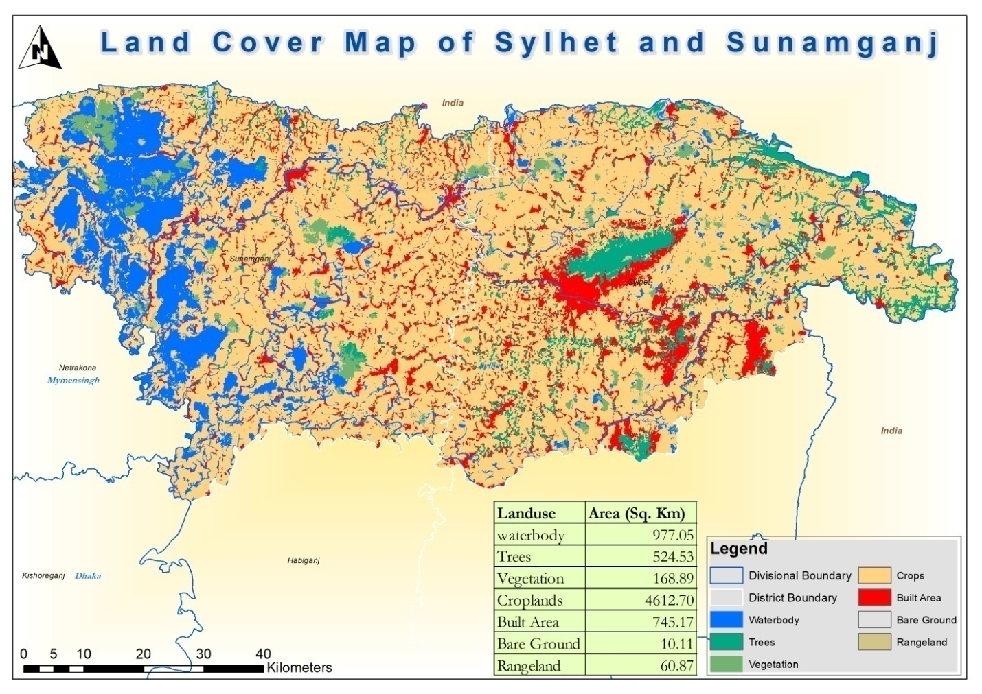

**Figure 1:** Overview of the study area of Bangladesh including water body, trees, vegetation, croplands, built rea, bare ground, rangeland

**2.2. Data collection**

For this study, data were downloaded from an online site, including climatic statistics from May 2022 to June 2022 for two districts in Bangladesh's northeast, Sylhet and Sunamganj. The study area's water level data were collected from Bangladesh Water Development Board (https://www.bwdb.gov.bd/) (S1). We also included various climate data parameters on a daily basis on the NASA Prediction of Worldwide Energy Resources websites, such as Rainfall (mm), relative humidity (%), temperatures (°C), surface pressure (kPa), and wind velocity (m/s) (NASA, 2020). We have stored all the R-codes required to replicate the results, adequately controlled our data management, and tested for data consistency. Added materials provide further information (S2). The highest and lowest temperature (Bhola (26.1995 ◦C) and Lalmonirhat (21.3966 ◦C) ) and relative humidity ((Lakshmipur (81.8055%) and Rajshahi (77.7943%) ) observed in different districts respectively, where the highest wind speed identified in the Narail district (9.044 m/s) (Figure -2)

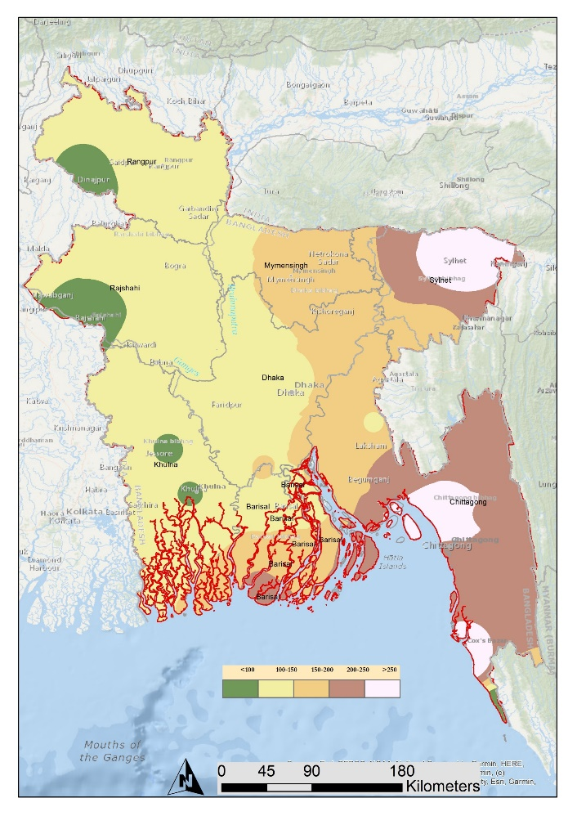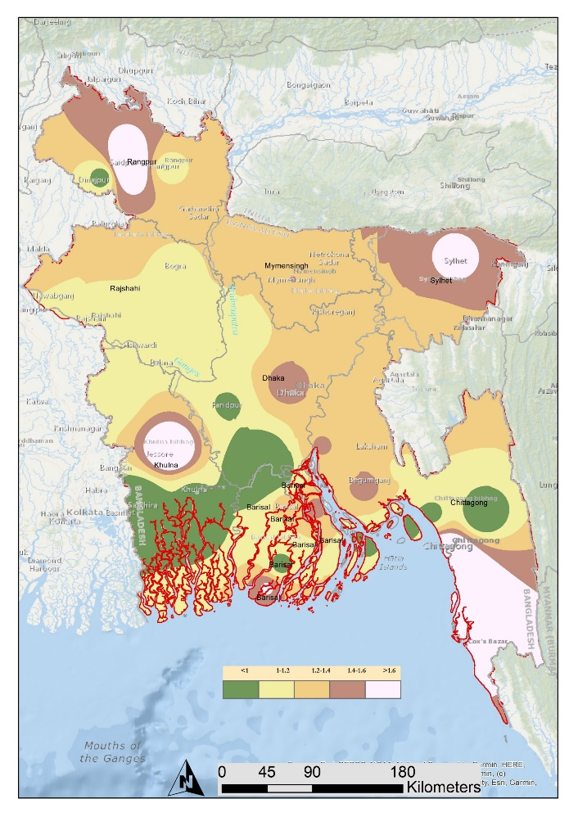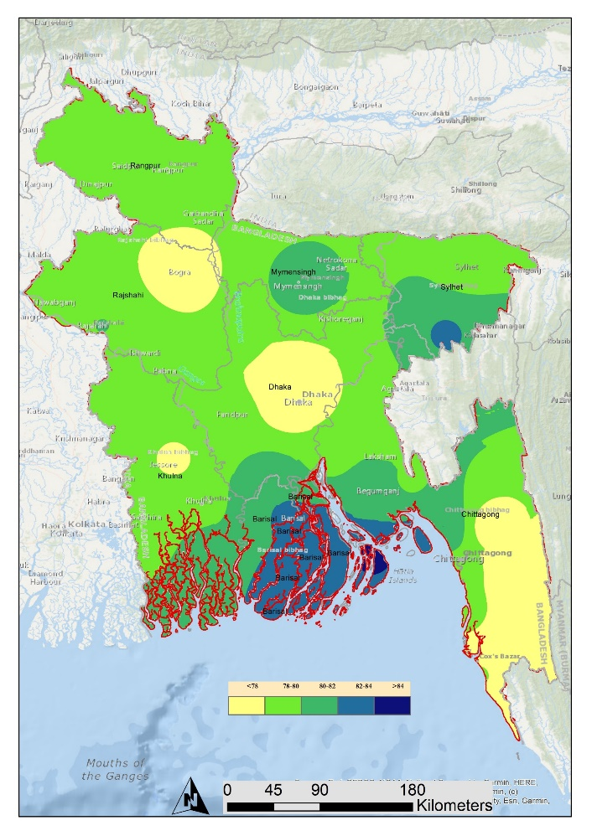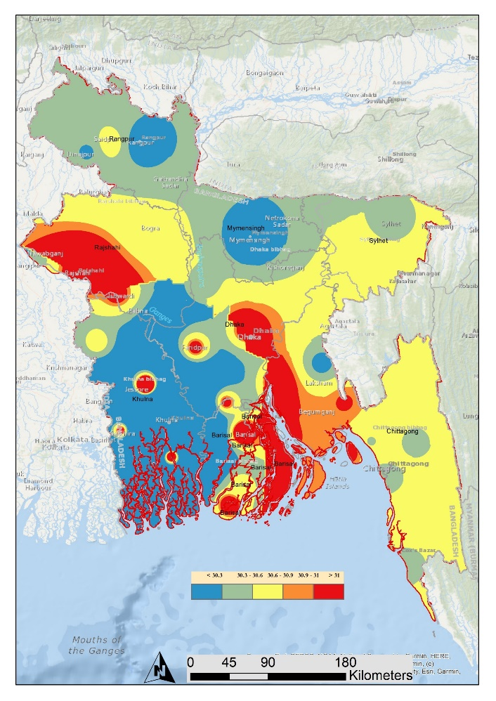

**Temperature**

e

**Wind Speed**

**Rainfall**

**Humidity**

**Figure 2:** Bangladesh map with climatic parameters-Temperature, wind, rainfall, humidity (yearly average)

**2.3 Time series model**

The ARIMAX model was used to evaluate the relationship between daily water level data and daily climatic variables. The ARIMAX model was developed for each district's time series of water level. We used R-square values, root means sum square error (RMSE), and mean absolute error (MAE) to identify the model performance for each district. An ARIMAX model is used in this study. ARIMA model is a standard model for data forecasting.

**3. Results and discussion:**

The paired t-test between the non-flooded and flooded area showed a significant variation between the two areas. The mean of the non-flooded area for May was 9126.4 and the standard deviation was 4927.1, whereas, in June, the mean of the non-flooded area was 7759.6,and the standard deviation was 4230.3 (Figure-3). Table 1 also showed that the mean difference of two months of the non-flooded area was 1241.21 in the Sylhet, which was negatively counted in the flooded area.

Table 1: Overall Difference between non-flooded and flooded areas of Sylhet and Sunamganj (paired t-test)

|  |  |  |  |  |  |  |  |  |  |  |  |  |
| --- | --- | --- | --- | --- | --- | --- | --- | --- | --- | --- | --- | --- |
| Sylhet | | | | | Sunamganj | | | | Total | | | |
| Mean (SD) | Non-flooded area | | Flooded area | | Non-flooded area | | Flooded area | | Non-flooded area | | Flooded area | |
| May | June | May | June | May | June | May | June | May | June | May | June |
| 9991.8 (5424.6) | 8750.6 (4718.2) | 18974.8 (7819.0) | 20216.0 (8330.1) | 8188.8 (4361.3) | 6685.9 (3512.9) | 23644.9 (9882.4) | 25147.7 (9817.6) | 9126.4 (4927.1) | 7759.6 (4230.3) | 21216.5 (9000.0) | 22583.2 (9230.1) |
| Mean Difference | 1241.21 | | -1241.21 | | 1502.84 | | -1502.84 | | 1366.79 | | -1366.80 | |
| P-value | 0.039 | | 0.039 | | 0.003 | | 0.003 | | <0.001 | | <0.001 | |

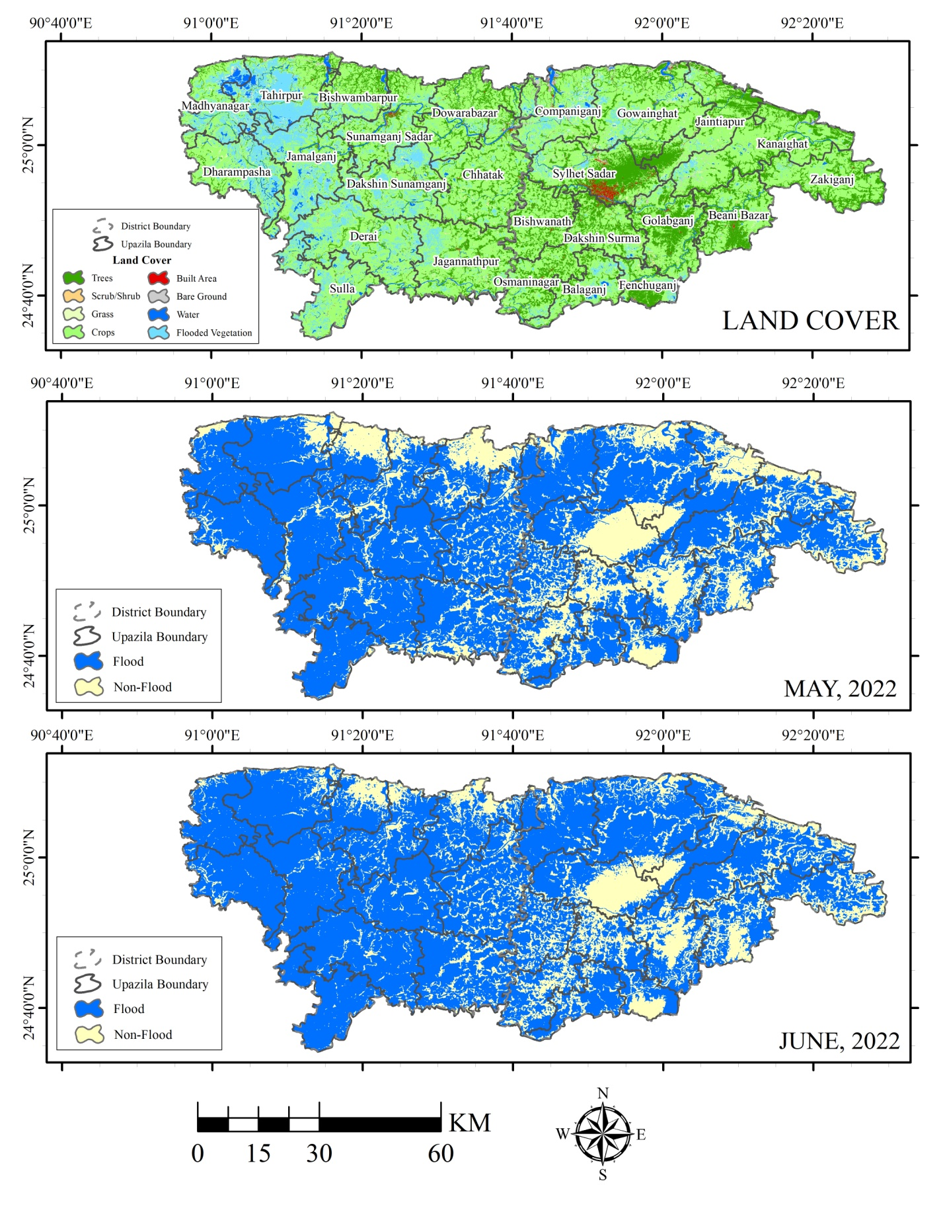

**Figure 3:** Flooded and non-flooded areas of the study zone, including district boundary and Upazila boundary

The highest mean of wind speed was recorded in Sunamganj, with a standard deviation of 2.1; the mean of temperature was recorded as highest in Sunamganj (29.3) and a standard deviation of 1.2. Sunamganj also showed the highest Rainfall and surface pressure. In contrast, the highest mean value of relative humidity was recorded in Sylhet (73.2) with a standard deviation of 10.0. Similarly, the water level was recorded as the highest also in Sylhet (Table 2).

Table 2: Descriptive study of weather factors between Sylhet and Sunamganj

|  |  |  |  |  |  |  |  |  |  |  |  |  |
| --- | --- | --- | --- | --- | --- | --- | --- | --- | --- | --- | --- | --- |
| Min | Sylhet | | | | | | Sunamganj | | | | | |
| WS | Temp | RH | Rain | SP | WL | WS | Temp | RH | Rain | SP | WL |
| 0.7 | 26.0 | 49.5 | 0.0 | 98.7 | 4.4 | 0.8 | 26.3 | 45.3 | 0.1 | 99.0 | 4.5 |
| Mean | 2.1 | 28.8 | 73.2 | 6.1 | 99.1 | 9.1 | 2.1 | 29.3 | 72.3 | 6.4 | 99.5 | 8.3 |
| SD | 0.9 | 1.2 | 10.0 | 7.0 | 0.2 | 2.5 | 0.9 | 1.2 | 11.2 | 7.4 | 0.2 | 1.8 |
| Max | 4.2 | 30.9 | 89.3 | 33.5 | 99.6 | 11.7 | 4.2 | 32.0 | 90.3 | 35.9 | 99.9 | 10.3 |

Table 3 shows the correlations between the meteorological factors in both Sylhet and Sunamganj. Although some sample correlations appear not numerically significant, the non-parametric spearman rank correlation test indicated that the correlation between WS with temperature, RH, and SP is significant at level 5%. Temp showed significant association with WS, RH, SP, and WL. RH found also significant correlation with WS, temperature, SP, and WL. Rain is significant with WS, temperature, RH, and WL. WL is significant with Temp, RH, and SP. WS negatively correlated with Temp (-0.4) and positively correlated with RH (0.5), SP (0.6), and WL (0.5) temperature negatively correlated with RH (-0.9), SP (-0.7), and WL (-0.8). RH was negatively correlated with temperature (-0.9) and positively correlated with WS (0.5), SP (0.8), and WL (0.8). Rain is negatively correlated with Temp (-0.7) and positively correlated with WS (0.6), RH (0.8), and WL (0.7). WL are negatively correlated with temperature (-0.8) and positively correlated with WS (0.5), RH (0.8), and SP (0.7). SP showed no relation with other meteorological variables.

Table 3: Correlation of weather factors between Sylhet and Sunamganj

|  |  |  |  |  |  |  |  |  |  |  |  |  |
| --- | --- | --- | --- | --- | --- | --- | --- | --- | --- | --- | --- | --- |
| WS | **Sylhet** | | | | | | **Sunamganj** | | | | | |
| **WS** | **Temp** | **RH** | **Rain** | **SP** | **WL** | **WS** | **Temp** | **RH** | **Rain** | **SP** | **WL** |
| 1.0 | -0.4 | 0.5 | 0.1 | 0.6 | 0.5 | 1.0 | -0.5 | 0.6 | -0.1 | 0.6 | 0.3 |
| Temp | -0.4 | 1.0 | -0.9 | -0.1 | -0.7 | -0.8 | -0.5 | 1.0 | -0.9 | 0.1 | -0.7 | -0.7 |
| RH | 0.5 | -0.9 | 1.0 | -0.2 | 0.8 | 0.8 | 0.6 | -0.9 | 1.0 | -0.3 | 0.7 | 0.7 |
| SP | 0.1 | -0.1 | -0.2 | 1.0 | -0.1 | 0.1 | -0.1 | 0.1 | -0.3 | 1.0 | -0.1 | -0.1 |
| Rain | 0.6 | -0.7 | 0.8 | -0.1 | 1.0 | 0.7 | 0.6 | -0.7 | 0.7 | -0.1 | 1.0 | 0.6 |
| WL | 0.5 | -0.8 | 0.8 | 0.1 | 0.7 | 1.0 | 0.3 | -0.7 | 0.7 | -0.1 | 0.6 | 1.0 |

In Sylhet city, the wind speed, RH, and SP have positive associations (Coefficient = 0.04, 95% CI: 0.02 to 0.30, 0.48 [0.20 to 1.16], 0.04 [-0.21 to 0.29], respectively) with the water level, but among them, SP was not statistically significant with water level according to ARIMAX model. The Temp and WL have negatively associated (-0.16 [-0.58 to -0.27] and -0.32 [-0.41 to -0.02], respectively) with water level according to the ARIMAX model. The ARIMAX model explains 98.70% of the overall variation with 0.7901 RMSE and 0.5550 MAE.

Table 4: Coefficient of ARIMAX model between Sylhet and Sunamganj

|  |  |  |  |  |  |  |
| --- | --- | --- | --- | --- | --- | --- |
| **WS** | **Sylhet** | | | **Sunamganj** | | |
| **Estimate** | **95% CI** | **P-value** | **Estimate** | **95% CI** | **P-value** |
| 0.04 | 0.02 to 0.30 | 0.007 | -0.04 | -0.29 to -0.01 | 0.008 |
| **Temp** | -0.16 | -0.58 to -0.27 | 0.047 | -0.24 | -0.72 to -0.11 | 0.032 |
| **RH** | 0.48 | 0.20 to 1.16 | 0.017 | 0.65 | 0.16 to 1.46 | 0.012 |
| **SP** | 0.04 | -0.21 to 0.29 | 0.765 | 0.17 | 0.10 to 0.44 | 0.022 |
| **WL** | -0.32 | -0.41 to -0.02 | 0.008 | 0.01 | 0.01 to 0.05 | 0.009 |
| **R-square** | 98.70% | | | 98.79% | | |
| **RMSE** | 0.7901 | | | 0.8069 | | |
| **MAE** | 0.5550 | | | 0.5497 | | |

In Sunamganj city, the RH, SP and WL has been found to be positively associated (0.65 [0.16 to 1.46], 0.17 [0.10 to 0.44], and 0.01 [0.01 to 0.05], respectively) with water level according to ARIMAX model. The WS and Temp are negatively associated (-0.04 [-0.29 to -0.01] and -0.24 [-0.72 to -0.11], respectively) with water level according to the ARIMAX model. The ARIMAX model explains 98.79% of the overall variation with 0.8069 RMSE and 0.5497 MAE. According to the forecast of Sylhet and Sunamganj, the WL is expected to increase considerably in the coming 10 days (Figure 4).

|  |
| --- |
| Sylhet |
|  |
| Sunamganj |
|  |

**Figure 4: ARIMAX model of Sylhet and Sunamganj [Precipitation vs Date]**

**4. Discussion**

Flood is not new in Bangladesh as this country faced six significant floods in the 19th century and 18 in the 20th century (Rasid & Paul, 1987). The country has periodically experienced severe floods due to "nonlinear geomorphological and hydrometeorological trends, unplanned land use practices including urban sprawl, deforestation and significant population growth (M. A. Islam., 2022a,b,c). Among those, the floods of 1951, 1987, 1988, 1998, and recently 2004 and 2010 were more dangerous. The 2022 flood in Bangladesh was also recorded as one of the most devastating floods in the current years; where 1987 flood affected 57,300 square kilometers or 40% area of the whole country and stayed in July and August. Another destructive flood was recorded in 1988, which flooded 60% of the country, about 82,000 square kilometers (32,000 sq mi). Notably, other floods observed in Bangladesh occurred in 1998,when over 75% area flooded, in 2004, 2005, 2007, 2015, and 2017 (A. S. Islam et al., 2010). Flash floods in Bangladesh are associated with a variety of factors. According to a researcher from IWFM, the rivers in Bangladesh have lost their water carrying capacity due to the siltation of riverbeds caused by solid waste dumping and deforestation. Thesignificant causes of flash floods in the hilly region are prolonged and intense rainfall events, landslides, breaches of the dam, human-induced development failure and the sudden intrusion of water from the upstream region (M. R. Chowdhury & Ward, 2007).

According to this study result, we can conclude that there is a significant difference between the mean of non-flooded areas for May and June (*P*<0.005). Changing climate significantly influences extreme events like erratic and excessive rainfall, and increased water in the upstream region due to hot weather (Ferdushi et al., 2019). Due to the changing environment, predicting extreme climatic events becomes more difficult for the weather forecaster. Additionally, ineffective and outdated early forecasting and warning technologies increase the damages and losses (di Baldassarre et al., 2014). In 2004 the northeastern flash flood was the worst among all, as the rainfall was 1.5 times higher than the average in the month of April. The flash flood caused damages worth 1,000 million US. Dollar and inundated 8,000 sq km/haor area of Sylhet, Sunamganj, Moulavi Bazar, and Habiganj district (Sarker & Rashid, 2013).The air consisted of high moisture content obstructed near the northeastern hills and forced to cause orographic uplift, making the air saturated and condensed to form an orographic cloud around the hilltop. The lower cloud is constantly replenished by strong surface flow of damp air during the monsoon, causing prolonged period of rainfall. It is also found that there is climatic correlation with natural calamity in other countries (Barrera-Escoda & Llasat, 2015). The descriptive result analysis of this study supported that the rainfall is higher in the district of Sunamganj rather than in Sylhet. Tanguar Haor usually faces increased rainfall in early June with the arrival of the monsoons (GUHATHAKURTA et al., 2011). Tanguar Haor receives backwaters from the Surma-Bauai, Patnai, and Jadukata river systems. The flow rate is low with a small sediment load, making the waters of Tanguar Haor relatively clear, evident in our water clarity measures. The changes in the physicochemical variables may not be evident unless combined in a factor analysis since the water level slowly rises through June to August and declines in September.

The population of Bangladesh is rapidly growing while arable land is rapidly diminishing (A. Islam et al., 2022a,b,c; Jakariya et al., 2021). Drought, salinity, extreme temperatures, emerging and reemerging pathogens, and other biotic and abiotic factors affect approximately 41.3% of the earth's surface, and this area continues to expand (S. Chakraborty et al., 2022a,b,c; Chandran et al., 2022; Dhama et al., 2022; Tiwari et al., 2023). Therefore, ensuring enough crop production by storing dry foods, enough education for activities during the flood, preservation of potable water, and seasonal awareness are necessary to minimize the catastrophic flood in the future.

**5. Steps to mitigate flood risk**

Following both non-structural (infrastructure- river corridor rehabilitation and restoration, channelization, bypass and diversion channels, detention and retention basins, embankments, dams and reservoirs), and structural actions (Land use regulations, flood forecasting and warning, flood proofing, emergency preparedness, response, and recovery, source control (watershed/landscape structure management), laws and regulations), it is possible to reduce the likelihood of natural disasters (Rahman et al., 2022). To reduce the risk of flooding, both governmental and nongovernmental efforts can be implemented. Several NGO's are working in Bangladesh to improve amenities for flood-prone communities after risk mitigation and resilience actions.

Natural solutions, often known as "grey infrastructure," which refers to measures to preserve ecosystems, particularly in rural areas, are an alternative method of reducing flood risk. It is a natural solution that uses environmental management techniques to lessen flood danger rather than regulate it (Hakim & Islam, 2022). The National Adaptation Plan to Combat Climate Adaptation (NAP), which will focus on Nature Based Solutions (NBS) and Ecosystem Based Adaptation (EbA), the Perspective Plan 2041 (PP2041), which is working on urban settings, and the Bangladesh Delta Plan 2100 (BDP), which creates a linkage with climate change, are some of the projects the Bangladesh government is pursuing to reduce flood risk. Other significant options, such increasing drainage depth and preserving urban wetlands, could be used to lower the danger (Govind & Alam, 2022).

Since the monsoon rainy season and precipitation are both associated with floods, understanding the monsoon rainfall pattern is essential for lowering the danger of flooding in Bangladesh. This season's length has direct and indirect effects on agricultural production. Floods are caused by too much rain, and the opposite situation results in drought. Forecasting this situation and disseminating it via social media is crucial. Many machine learning methods, including support vector machines (SVM), random forests (RF), convolution neural networks (CNN), and long short-term memory (LSTM) models to forecast climatic water balance (CWB), can be used to comprehend and predict the pattern of the monsoon season (Azad et al., 2022).

**6. Conclusion and future plans**

Bangladesh is one of the most vulnerable countries in the world due to climatic factors. This country has experienced a hazardous and extreme situation with 2022 flood. Although natural calamities like floods, droughts, and cyclones are not directly interlinked with anthropogenic factors, the environment and environmental parameters are intertwined with these disasters. This study proved that climatic factors are associated with flood 2022 in Bangladesh. As these typesof dreadful floods will again strike the northeast region in the future, it is high time actions were taken to protect the environment. Taking steps for forecasting, making high-stored buildings, and storing dry food can be anticipatory actions for proactive measures against the flood. Although forecasting floods is challenging, technical teams may work to expand and develop early forecasting systems. The humanitarian work and responses may lessen the damage of flood. More than 82 humanitarian agencies from government and non-government organizations helped in this 2022 flood, notably the Bangladesh Red Crescent Society, and several UN agencies and non-governmental organizations (NGOs). This is also noted that research-based experiments need to be conducted to explore the correlation between flood and other factors. These study findings indicate an association between the 2022 flood and the climate in Bangladesh. Minimizing the hazardous effect of these natural floods requires multidisciplinary action where the depth of the river by the government of Bangladesh is needed.

# 7. Ethical statement

This data-based study does not require any ethical permission.

# 8. Authors contribution

MAI and MNH have completed analysis and manuscript writing. All coauthors reviewed and edited this manuscript.

# 9. Declaration of competing interest

The authors declare that they have no known competing financial interests or personal relationships that could have influenced the work reported in this paper.

# 10. Acknowledgments

We acknowledge all of the coauthor’s instruction in this manuscript. All authors also acknowledge reviewers and chief in editor of [Groundwater for Sustainable Development](https://www.sciencedirect.com/journal/groundwater-for-sustainable-development) journal.

# 11. Funding Sources

This study was supported by President Abdul Medical College Hospital, Noakhali Science and Technology University.

**12. Reference**

Ahmed, F., Islam, M. A., Kumar, M., Hossain, M., Bhattacharya, P., Islam, M. T., Hossen, F., Hossain, M. S., Islam, M. S., Uddin, M. M., Islam, M. N., Bahadur, N. M., Didar-ul-Alam, M., Reza, H. M., & Jakariya, M. (2021). First detection of SARS-CoV-2 genetic material in the vicinity of COVID-19 isolation Centre in Bangladesh: Variation along the sewer network. *Science of The Total Environment*, *776*, 145724. https://doi.org/10.1016/j.scitotenv.2021.145724

Baksi, A. K. (2022). Geochemistry and geochronology of the Rajmahal Flood Basalt Province, northeastern India: Genetic links to Kerguelen hotspot activity. *Journal of Earth System Science*, *131*(3), 157. https://doi.org/10.1007/s12040-022-01855-8

Barrera-Escoda, A., & Llasat, M. C. (2015). Evolving flood patterns in a Mediterranean region (1301–2012) and climatic factors – the case of Catalonia. *Hydrology and Earth System Sciences*, *19*(1), 465–483. https://doi.org/10.5194/hess-19-465-2015

Baser, S., & Abu Hasnath, S. (2022). The Rise and Fall of the NGOs in Bangladesh: What Does the Future Hold? In *Non-government Organizations - New Perspectives [Working Title]*. IntechOpen. https://doi.org/10.5772/intechopen.107855

Chakraborty, C., Bhattacharya, M., Sharma, A. R., Roy, S. S., Islam, M. A., Chakraborty, S., Nandi, S. S., & Dhama, K. (2022). Deep learning research should be encouraged for diagnosis and treatment of antibiotic resistance of microbial infections in treatment associated emergencies in hospitals. *International Journal of Surgery*, *105*, 106857. https://doi.org/10.1016/j.ijsu.2022.106857

Chakraborty, S., Chandran, D., Mohapatra, R. K., Islam, M. A., Alagawany, M., Bhattacharya, M., Chakraborty, C., & Dhama, K. (2022). Langya virus, a newly identified Henipavirus in China - Zoonotic pathogen causing febrile illness in humans, and its health concerns: Current knowledge and counteracting strategies – Correspondence. *International Journal of Surgery*, *105*, 106882. https://doi.org/10.1016/j.ijsu.2022.106882

Chakraborty, S., Chandran, D., Mohapatra, R. K., Yatoo, M. I., Islam, A., Sharma, A. K., Alagawany, M., & Dhama, K. (2022). *Journal of Experimental Biology and Agricultural Sciences Marburg Virus Disease – A Mini-Review*. *10*(2320), 689–696.

Chakraborty, S., Mohapatra, R. K., Chandran, D., Alagawany, M., Sv, P., Islam, M. A., Chakraborty, C., & Dhama, K. (2022). Monkeypox vaccines and vaccination strategies: Current knowledge and advances. An update – Correspondence. *International Journal of Surgery*, *105*, 106869. https://doi.org/10.1016/j.ijsu.2022.106869

Chandran, D., Dhama, K., K, M. A. M., Chakraborty, S., Mohapatra, R. K., Yatoo, M. I., Islam, A., Alagawany, M., Sharma, A. K., Mohankumar, P., Panalil, A. Das, & Chandran, D. (2022). *Journal of Experimental Biology and Agricultural Sciences Monkeypox : An Update on Current Knowledge and Research Advances*. *10*(2320), 679–688.

Chowdhury, M. R., & Ward, M. N. (2007). Seasonal flooding in Bangladesh – variability and predictability. *Hydrological Processes*, *21*(3), 335–347. https://doi.org/10.1002/hyp.6236

Chowdhury, N. I. (2022). Right to Health in Bangladesh in the Situation of Post Natural Calamities: An Analytical Overview. *SSRN Electronic Journal*. https://doi.org/10.2139/ssrn.4261146

Das, P., Ahmad, F., Rahman, A., & Khan, M. S. M. (2022). *A Study on Flood Inundation Mapping of Surma River Floodplain Under Extreme Flood Scenario* (pp. 499–513). https://doi.org/10.1007/978-981-19-1600-7_32

Dhama, K., Chandran, D., Chakraborty, S., Yatoo, M. I., Islam, M. A., Bhattacharya, M., Chakraborty, C., Harapan, H., & Chaicumpa, W. (2022). Zoonotic concerns of Marburg virus: Current knowledge and counteracting strategies including One Health approach to limit animal-human interface: An update. *International Journal of Surgery*, *106*, 106941. https://doi.org/10.1016/j.ijsu.2022.106941

di Baldassarre, G., Yan, K., Ferdous, M. R., & Brandimarte, L. (2014). The interplay between human population dynamics and flooding in Bangladesh: a spatial analysis. *Proceedings of the International Association of Hydrological Sciences*, *364*, 188–191. https://doi.org/10.5194/piahs-364-188-2014

Ferdushi, Ismail, & Kamil. (2019). Perceptions, Knowledge and Adaptation About Climate Change: A Study on Farmers of Haor Areas After a Flash Flood in Bangladesh. *Climate*, *7*(7), 85. https://doi.org/10.3390/cli7070085

Gepp, S., Waid, J. L., Brombierstäudl, D., Kader, A., Müller-Hauser, A. A., Wendt, A. S., Dame, J., & Gabrysch, S. (2022). Impact of unseasonable flooding on women’s food security and mental health in rural Sylhet, Bangladesh: a longitudinal observational study. *The Lancet Planetary Health*, *6*, S14. https://doi.org/10.1016/S2542-5196(22)00276-5

GUHATHAKURTA, P., SREEJITH, O. P., & MENON, P. A. (2011). Impact of climate change on extreme rainfall events and flood risk in India. *Journal of Earth System Science*, *120*(3), 359–373. https://doi.org/10.1007/s12040-011-0082-5

Haque, M. A., Wang, F., Chen, Y., Hossen, F., Islam, M. A., Hossain, M. A., Siddique, N., He, C., & Ahmed, F. (2022). Bacillus spp. Contamination: A Novel Risk Originated From Animal Feed to Human Food Chains in South-Eastern Bangladesh. *Frontiers in Microbiology*, *12*. https://doi.org/10.3389/fmicb.2021.783103

Hossain, F. E., Islam, S., Islam, M. A., Islam, S., & Ahmed, F. (2021). Detection of virulence genes of APEC (avian pathogenic Escherichia coli) isolated from poultry in Noakhali, Bangladesh. *Bioresearch Communications*, *7*(1), 967–972. https://doi.org/10.3329/brc.v7i1.54253

Hossain, M., Saiha Huq, T., Rahman, A., Aminul Islam, M., Naushin Tabassum, S., Nadim Hasan, K., Khaleque, A., Sadique, A., Salim Hossain, M., Mohammed Bahadur, N., Ahmed, F., & Mahmud Reza, H. (2021). *Novel mutations identified from whole-genome sequencing of SARS-CoV-2 isolated from Noakhali, Bangladesh*.

Islam, A., Hossen, F., Rahman, A., Sultana, K. F., Hasan, M. N., Haque, A., Sosa-Hernández, J. E., Oyervides-Muñoz, M. A., Parra-Saldívar, R., Ahmed, T., Islam, T., Dhama, K., Sangkham, S., Bahadur, N. M., Reza, H. M., Jakariya, Al Marzan, A., Bhattacharya, P., Sonne, C., & Ahmed, F. (2022). An opinion on Wastewater-Based Epidemiological Monitoring (WBEM) with Clinical Diagnostic Test (CDT) for detecting high-prevalence areas of community COVID-19 Infections. *Current Opinion in Environmental Science & Health*, 100396. https://doi.org/10.1016/j.coesh.2022.100396

Islam, A., Rahman, A., Jakariya, Bahadur, N. M., Hossen, F., Mukharjee, S. K., Hossain, M. S., Tasneem, A., Haque, M. A., Sera, F., Jahid, I. K., Ahmed, T., Hasan, M. N., Islam, T., Hossain, A., Amin, R., Tiwari, A., Didar-Ul-Alam, M., Dhama, K., … Ahmed, F. (2022). A 30-day follow-up study on the prevalence of SARS-COV-2 genetic markers in wastewater from the residence of COVID-19 patient and comparison with clinical positivity. *Science of The Total Environment*, 159350. https://doi.org/10.1016/j.scitotenv.2022.159350

Islam, A. S., Bala, S. K., & Haque, M. A. (2010). Flood inundation map of Bangladesh using MODIS time-series images. *Journal of Flood Risk Management*, *3*(3), 210–222. https://doi.org/10.1111/j.1753-318X.2010.01074.x

Islam et al.;2021. (n.d.). *Sex-specific epidemiological and clinical characteristics of COVID-19 patients in the southeast region of Bangladesh 2021.MedRxivhttps://doi.org/10.1101/2021.07.05.21259933.* https://doi.org/doi.org/10.1101/2021.07.05.21259933.

Islam, M. A., Haque, M. A., Rahman, M. A., Hossen, F., Reza, M., Barua, A., Marzan, A. Al, Das, T., Kumar Baral, S., He, C., Ahmed, F., Bhattacharya, P., & Jakariya, M. (2022). A Review on Measures to Rejuvenate Immune System: Natural Mode of Protection Against Coronavirus Infection. *Frontiers in Immunology*, *13*. https://doi.org/10.3389/fimmu.2022.837290

Islam, M. A., Hasan, M. N., Ahammed, T., Anjum, A., Majumder, A., Siddiqui, M. N.-E.-A., Mukharjee, S. K., Sultana, K. F., Sultana, S., Jakariya, M., Bhattacharya, P., Sarkodie, S. A., Dhama, K., Mumin, J., & Ahmed, F. (2022). Association of household fuel with acute respiratory infection (ARI) under-five years children in Bangladesh. *Frontiers in Public Health*, *10*. https://doi.org/10.3389/fpubh.2022.985445

Islam, M. A., Sangkham, S., Tiwari, A., Vadiati, M., Hasan, M. N., Noor, S. T. A., Mumin, J., Bhattacharya, P., & Sherchan, S. P. (2022). Association between Global Monkeypox Cases and Meteorological Factors. *International Journal of Environmental Research and Public Health*, *19*(23), 15638. https://doi.org/10.3390/ijerph192315638

Jakariya, M., Ahmed, F., Islam, M. A., Ahmed, T., Marzan, A. Al, Hossain, M., Reza, H. M., Bhattacharya, P., Hossain, A., Nahla, T., Bahadur, N. M., Hasan, M. N., Islam, M. T., Hossen, M. F., Alam, M. D. ul, Mou, N., & Jahan, H. (2021). Wastewater based surveillance system to detect SARS-CoV-2 genetic material for countries with on-site sanitation facilities: an experience from Bangladesh. *MedRxiv*, *8852000*, 2021.07.30.21261347.

Masrur, A., Dewan, A., Botje, D., Kiselev, G., & Murshed, M. M. (2022). Dynamics of human presence and flood-exposure risk in close proximity to Bangladesh’s river network: an evaluation with multitemporal satellite imagery. *Geocarto International*, 1–17. https://doi.org/10.1080/10106049.2022.2093410

Islam MA, Suleiman AS, Kaifa FH, Lorenzo JM, Bhattacharya P and Dhama K (2022) A bibliometric study on Marburg virus research and prevention and control strategies. Front. Trop. Dis. 3:1068364. doi: 10.3389/fitd.2022.1068364

Noor, F., Haq, S., Rakib, M., Ahmed, T., Jamal, Z., Siam, Z. S., Hasan, R. T., Adnan, M. S. G., Dewan, A., & Rahman, R. M. (2022). Water Level Forecasting Using Spatiotemporal Attention-Based Long Short-Term Memory Network. *Water*, *14*(4), 612. https://doi.org/10.3390/w14040612

Pervin, I. A., Rahman, S. M. M., Nepal, M., Haque, A. K. E., Karim, H., & Dhakal, G. (2020). Adapting to urban flooding: a case of two cities in South Asia. *Water Policy*, *22*(S1), 162–188. https://doi.org/10.2166/wp.2019.174

Rakib, S. H. (2022). *Design of a cost-effective Ultraviolet Disinfection unit to minimize the cross-contamination of COVID-19 in transport*. 2–7.

Rakib, S. H., Masum, S. ., Patwari, M. R. I., Fahima, R. A., Farhana, A., & Islam, M. A. (2021). Design and Development of a low cost Ultraviolet Disinfection system to reduce the cross infection of SARS-CoV-2 in ambulances. *2021 International Conference on Electronics, Communications and Information Technology (ICECIT)*, 1–4. https://doi.org/10.1109/ICECIT54077.2021.9641131

Rasid, H., & Paul, B. K. (1987). Flood problems in Bangladesh: Is there an indigenous solution? *Environmental Management*, *11*(2), 155–173. https://doi.org/10.1007/BF01867195

Roy, S., Bhowmik, D. R., Begum, R., Amin, M. T., Islam, M. A., Ahmed, F., & Hossain, M. S. (2022). Aspirin attenuates the expression of adhesion molecules, risk of obesity, and adipose tissue inflammation in high-fat diet-induced obese mice. *Prostaglandins & Other Lipid Mediators*, *162*, 106664. https://doi.org/10.1016/j.prostaglandins.2022.106664

Roy, S., Ripon, M. A. R., Begum, R., Bhowmik, D. R., Amin, M. T., Islam, M. A., Ahmed, F., & Hossain, M. S. (2022). Arachidonic acid supplementation attenuates adipocyte inflammation but not adiposity in high fat diet induced obese mice. *Biochemical and Biophysical Research Communications*, *608*, 90–95. https://doi.org/10.1016/j.bbrc.2022.03.089

Sakib, M. M. H., Nishat, A. A., Islam, M. T., Raihan Uddin, M. A., Iqbal, M. S., Bin Hossen, F. F., Ahmed, M. I., Bashir, M. S., Hossain, T., Tohura, U. S., Saif, S. I., Jui, N. R., Alam, M., Islam, M. A., Hasan, M. M., Sufian, M. A., Ali, M. A., Islam, R., Hossain, M. A., & Halim, M. A. (2021). Computational screening of 645 antiviral peptides against the receptor-binding domain of the spike protein in SARS-CoV-2. *Computers in Biology and Medicine*, *136*, 104759. https://doi.org/10.1016/j.compbiomed.2021.104759

Sarker, A. A., & Rashid, A. K. M. M. (2013). *Landslide and Flashflood in Bangladesh* (pp. 165–189). https://doi.org/10.1007/978-4-431-54252-0_8

Sincavage, R., Liang, M., Pickering, J., Goodbred, S., & Passalacqua, P. (2022). Antecedent Topography and Sediment Dispersal: The Influence of Geologically Instantaneous Events on Basin Fill Patterns. *Journal of Geophysical Research: Earth Surface*, *127*(6). https://doi.org/10.1029/2021JF006539

Tiwari, A., Adhikari, S., Kaya, D., Islam, M. A., Malla, B., Sherchan, S. P., Al-Mustapha, A. I., Kumar, M., Aggarwal, S., Bhattacharya, P., Bibby, K., Halden, R. U., Bivins, A., Haramoto, E., Oikarinen, S., Heikinheimo, A., & Pitkänen, T. (2023). Monkeypox outbreak: Wastewater and environmental surveillance perspective. *Science of The Total Environment*, *856*, 159166. https://doi.org/10.1016/j.scitotenv.2022.159166